[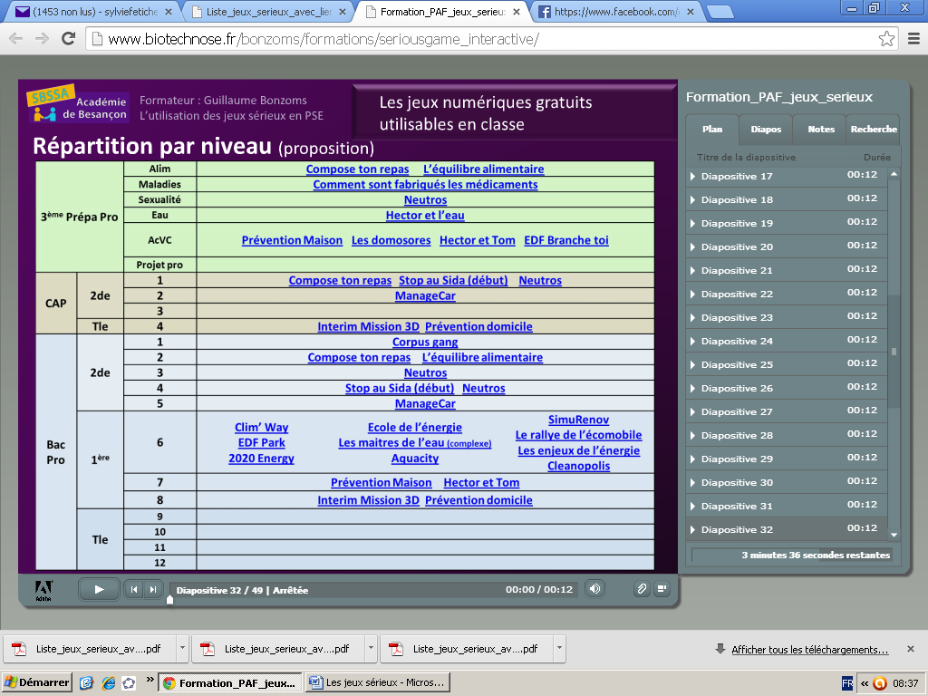](file:///F:\Ecole\Mission%20inspectrice\Documents%20de%20mise%20en%20ligne\Tableau%20jeux%20PSE.docx)